Isabella Felton
Professor Banks
Strategic Communications Writing
April 25, 2023

Final Portfolio

This was an individual project created by me, using USA Swimming’s likeness.

Table of Contents:

News Release…………………………………………………………………………………..3
Media Advisory………………………………………………………………………………..5
Fact Sheet……………………………………………………………………………………...6
Feature Story…………………………………………………………………………………..7
Radio Advertisement Script…………………………………………………………………...9
Social Media Calendar………………………………………………………………………...10
Brochure……………………………………………………………………………………….11
Crisis Communication Plan………………...………………………………………………….12



FOR IMMEDIATE RELEASE
Contact: Katie Ledecky, Senior Manager of Corporate Communications for USA Swimming
Phone: (123) 456-7890
Email: kaledecky@usaswimming.org

USA SWIMMING NAMES ISABELLA FELTON AS CHIEF COMMERCIAL OFFICER
Nike Veteran sends waves through the industry as the first lesbian woman becomes a communications executive


[COLORADO SPRINGS, COLORADO, January 2nd, 2023—] Isabella Felton has joined the USA Swimming executive board. As Chief Commercial Officer, she will oversee communications, sponsorship sales, revenue generation, marketing, creative, event marketing, business intelligence, digital platforms, media rights, and fundraising development. Isabella is from Piedmont, Oklahoma where she swam at the club level for USA Swimming and for her high school team. She received her bachelor’s in strategic communications and creative writing at Oklahoma City University and her master’s in business administration at the University of Chicago. With a decade of experience working at Nike as head manager of communications through a media embargo, Isabella is a skilled communicator and a master of risk management.

While at Nike, she oversaw the wave of new technological generation and was a pioneer in changing the internal communications game with software she founded, called “Bella Comm”. She also worked for Oklahoma City University in their communications department as an entry level media designer post-grad. In the past year, she was recognized on the Forbes 40 under 40 list for her innovative and influential techniques in the communications industry. Isabella was proudly the first lesbian woman to be a senior executive at Nike. In her time at that company, she helped to negotiate a 27-million-dollar merger with Sketchers. Isabella is also proud to be the first lesbian woman to be a senior executive at USA Swimming and aligns with President and CEO Michael Phelps’ mission to create a more inclusive and diverse board.

“Isabella fits our quality ideal of what a person, swimmer, and leader should be,” Phelps said. “Our organization will benefit from her experience and knowledge in the field and help create inclusive and diverse programming for our community. As a former swimmer, Isabella understands the drive and strength that our swimmers have, of all identities and backgrounds. We’re excited to watch her help us negotiate new partnerships, strengthen old ones, and create healthier environment in and outside the office.”

Isabella’s first day on the job will be February 15th of this year and will report to Phelps directly.

USA Swimming is responsible for selecting and training teams for international competition, including the Olympic Games, and administer competitive swimming in accordance with the Ted Stevens Olympic & Amateur Sports Act.]

###

If you would like more information about this topic, please call Katie Ledecky at (123) 456-7890, or email kaledecky@usaswimming.org.



FOR IMMEDIATE RELEASE
Feb. 9, 2023
USA Swimming Media Advisory
USA Swimming plans a media conference to announce new partnership with US Equestrian

What: Brendan Hansen, Director of Team Services for USA Swimming, will announce the organization’s strategic partnership with US Equestrian and a program at 9:30 a.m., Friday, Feb. 10, in the AT&T Center at USA Swimming headquarters. Hansen will reveal the exciting new program at the media conference.

Who: Hansen and the CEO of US Equestrian, Ryan Reynolds, will talk about the new partnership and goals for the two organizations, and then reveal the program. Both will take questions. A transcript of the conference will be available for media personnel at the conclusion of the event. At the same time, multimedia information along with program details and initiatives will be distributed and made available on USA Swimming’s website.

Where: USA Swimming headquarters are at 1 Olympic Plaza, Colorado Springs, CO. The AT&T Center is in the northern part of the Olympic Training Center and free parking for media personnel is available.

When: The media conference starts at 9:30 a.m., Friday, Feb. 10, and will last 60 minutes.

How: Access to the AT&T Center parking lot will be through a drive through media credentials checkpoint.

###

For more information:
Katie Ledecky
Senior Manager of Corporate Communications
(123) 456-7890
kaledecky@usaswimming.org

FOR IMMEDIATE RELEASE Contact: Katie Ledecky, Senior Manager of Corporate Communications for USA Swimming
Phone: (123) 456-7890
Email: kaledecky@usaswimming.org

USA SWIMMING NAMES ISABELLA FELTON AS CHIEF COMMERCIAL OFFICER

WHAT
- USA Swimming has hired a new Chief Commercial Officer for their executive board.
- Chief Commercial Officers oversee communications, sponsorship sales, revenue generation, marketing, creative, event marketing, business intelligence, digital platforms, media rights, and fundraising development.

WHO
- Isabella Felton is the new hire for this position.
- She received her bachelor’s in strategic communications and creative writing at Oklahoma City University and her master’s in business administration at the University of Chicago.
- Isabella worked at Nike for 10 years as head manager of communications. In her time at that company, she helped to negotiate a 27-million-dollar merger with Sketchers.
- She also worked for Oklahoma City University in their communications department as an entry level media designer post-grad. In the past year, she was recognized on the Forbes 40 under 40 list.

WHERE
- USA Swimming headquarters are at 1 Olympic Plaza, Colorado Springs, CO.

WHEN
- The organization announced this on January 2nd, 2023.
- Isabella’s first day will by February 15th, 2023.

###

FOR IMMEDIATE RELEASE
Feb. 9, 2023

USA Swimming News Release
USA Swimming plans a media conference to announce new partnership with US Equestrian

[COLORADO SPRINGS, COLORADO, March 1st, 2023—] At last week’s Zones Championship meet, coaches and swimmers alike were buzzing about USA Swimming teasing an exciting new partnership with US Equestrian.

“We’ve never done anything like this before,” Brendan Hansen, Director of Team Services says. “Not only is it new for us [USA Swimming and US Equestrian] on the business and implementation side of things, but our members, our coaches and officials and swimmers, this program just isn’t offered in our industry. And we wouldn’t have been able to do it without the expertise and insight of US Equestrian.”

The strategic partnership of USA Swimming and US Equestrian have been in talks since May of last year between executives. The program, which is the brainchild of Hansen and Bill Moroney, the CEO of US Equestrian, will be announced on Friday, Feb. 10, in the AT&T Center at USA Swimming headquarters. Hansen and Moroney will discuss the hopes for the partnership and then reveal the program to the public. At the same time, multimedia information along with program details and initiatives will be distributed and made available on USA Swimming’s website. The floor will be opened for questions.

“We’re just thrilled,” Moroney says. “Rarely do two big organizations join forces like to bring something truly great to our members. US Equestrian admires USA Swimming’s commitment to their members, a value that we hold very dear. We’re looking forward to a long and bright future with them.”

The media conference starts at 9:30 a.m., Friday, Feb. 10, and will last 60 minutes. USA Swimming headquarters are at 1 Olympic Plaza, Colorado Springs, CO. The AT&T Center is in the northern part of the Olympic Training Center and free parking for media personnel is available. Access to the AT&T Center parking lot will be through a drive through media credentials checkpoint. A transcript of the conference will be available for media personnel at the conclusion of the event.

###

For more information:
Katie Ledecky
Senior Manager of Corporate Communications
(123) 456-7890
kaledecky@usaswimming.org

Title: KICK SET!
Client/Sponsor: USA Swimming
Length: 30 seconds
Air Dates: 03/15/2023 – 04/15/2023

Want to be up to speed on all things swimming? Tune into AM 87.1 for KICK SET! on weekday mornings at 8 AM with retired Olympian Missy Franklin. Best workout sets? Interviews with decorated Olympians? Michael Phelps’ diet and exercise regimen? We’ve got it all. KICK SET! Is brought to you by USA Swimming, the National Governing Body for the sport of swimming in the United States. That’s KICK SET! with Missy Franklin. Dive in with us weekday mornings at 8 AM on AM 87.1 for KICK SET!

Social Media Calendar


Brochure
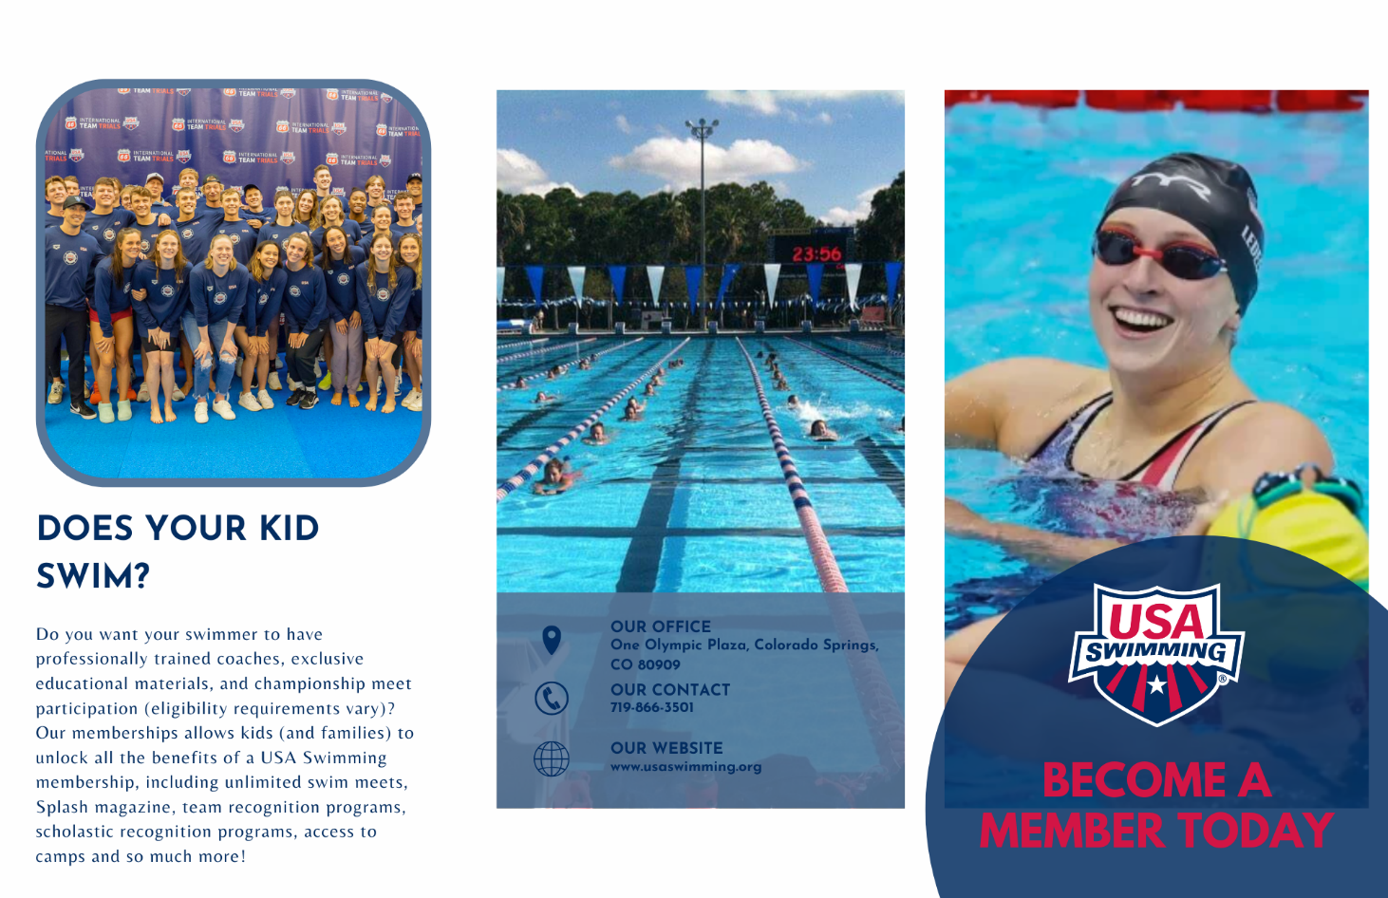

Crisis Management and Communication Plan

Last Updated May 1, 2023

Table of Contents

- Purpose
- Escalation Framework
  - First Line of Defense
  - Greater Response Team
- Roles and Responsibilities
- Do’s and Don’ts
- Maintaining an Effective Response Plan

Purpose

The purpose of this document is to assist when there is, well, a crisis! Essentially, to address any crises that affect our organization, internally and externally, and to make sure we as an organization are transparent and hold true to our values. Stevenson University defines a crisis communication plan as a blueprint for an organization in times of crisis, so that we can respond immediately. It is an emergency plan that includes steps of communication and future prevention to help prepare and navigate us through unexpected crises.

Such crises could be related to the following matters: financial, personnel, organizational, technological, natural, confrontation, workplace violence, or crisis of malevolence. The crises that this document could converted are not confined to this list as any situation where communication from USA Swimming is warranted is considered a crisis. The goal is to have this document be able to apply to all of them.

Our swimmers, coaches, parents, officials, staff and administration are all valued members of USA Swimming, and deserve our transparency, even in stressful situations. They will feel safer in our sport only when we so.

Escalation Framework

Level | Description | Action
Level 1 | This is the highest crisis escalation level which is considered the worst-case scenario and requires all hands-on deck. Everything action must be done immediately. This could be anything considered a high-level controversy or “scandal”. This crisis could be:  - violent in nature  - misconduct of a high level executive  - sexual abuse by members  - global crises such as the COVID-19 pandemic  - death of a USA Swimming Member  - devastating destruction of USA Swimming property  - shooting or terrorist attack  Action must be taken immediately, give no statements without being advised by CCO and General Counsel | - Chief Executive Officer (Michael Phelps): Immediately communicate situation with Leadership Team and Board of Directors, and set up a meeting with CCO and General Counsel to write a statement to go out to the public and a meeting with Leadership Team (and Board of Directors) to discuss further action, be prepared to give statements.  - Leadership Team: Immediately contact Board of Directors for a meeting, be prepared to give statements.  - Board of Directors: Immediately set up a time to meet and discuss.  - Chief Commercial Officer (Shana Ferguson): Immediately advise the aforementioned members and begin writing statements.  - Chief Financial Officer (Eric Skufca), Managing Director of Sport Development (Joel Shinofield), Managing Director for National Team (Lindsay Mintenko), Executive Administrative Assistant and VIP Hospitality Coordinator (Paula D'Amico): Advise Leadership Team on further action and statements respective to areas of expertise, be prepared to give statements to public respective of expertise  - Secretary & General Counsel (Michelle Steinfeld): Immediately advise the aforementioned members and begin possible legal action.  - Communications Team: Evaluate situation and proceed accordingly.
Level 2 | This is the moderate crisis escalation level which presents a long-term risk to the organization. This could be anything that threatens or could impact organizational reputation and could garter immediate consumer lash back. This crisis could be:  - Abrupt resignation of a high-level executive  - Scandal with an Olympian  - Allegations of any kind  - Minor/moderate destructive of USA Swimming facilities by natural disasters | - Chief Executive Officer (Michael Phelps): Communicate situation with Leadership Team and set up a meeting with CCO and General Counsel for advisement. Meet with Leadership Team (and Board of Directors if necessary) to discuss further action.  - Leadership Team: Let Board of Directors know of the situation and discuss further action.  - Board of Directors: Discuss issue and plan further action.  - Chief Commercial Officer (Shana Ferguson): Advise the aforementioned members and begin thinking about writing statements.  - Chief Financial Officer (Eric Skufca), Managing Director of Sport Development (Joel Shinofield), Managing Director for National Team (Lindsay Mintenko), Executive Administrative Assistant and VIP Hospitality Coordinator (Paula D'Amico): Advise Leadership Team on further action and statements respective to areas of expertise, be prepared to give statements to public respective of expertise.  - Secretary & General Counsel (Michelle Steinfeld): Advise the aforementioned members and begin possible legal action.  - Communications Team: Evaluate situation and proceed accordingly.
Level 3 | This is the low crisis escalation level which could present a short-term risk to the organization. This is unlikely to affect or impact organizational reputation. This crisis could be:  Examples include:  - An executive leave of absence  - Cancelation of major swim meets/conferences/championships due to weather or otherwise  - Rumors circulating | - Chief Commercial Officer (Shana Ferguson): Communicate situation with Communications Team to discuss further action further action if necessary and report to Leadership Team.  - Communications Team: Evaluate situation and proceed accordingly.
Level 4 | This is the lowest crisis escalation level which deals with the slightly bigger day to day threats of the organization. This is unlikely to affect or impact organizational reputation. This crisis could be:  Examples include:  - Members on social media airing their concerns  - Social media or website outage | - Chief Commercial Officer (Shana Ferguson): Communicate situation with Communications Team to discuss further action further action if necessary and report to Leadership Team.  - Communications Team: Evaluate situation and proceed accordingly.

Incident Response Team

The purpose of this team is to come together in a time of crisis and are those to directly respond to it, publicly and privately. It’s responsible for communicating the crisis to the public and coming to a sort of resolution.

The First Line of Defense

All crisis levels involve the following teams:

Communications Team
- Chief Commercial Officer (Shana Ferguson)
  - saferguson@usaswimming.org
  - (976) 427-4389
Executive Team
- Executive Administrative Assistant and VIP Hospitality Coordinator (Paula D'Amico)
  - pedamico@usaswimming.org
  - (866) 423-8541
Business Affairs
- Secretary & General Counsel (Michelle Steinfeld)
  - masteinfeld@usaswimming.org
  - (999) 425-3366
Team Services
- Senior Advisor, Team Services (Mitch Gold)
  - mlgold@usaswimming.org
  - (765) 678-9331
Group email chain for Incident Response Team through Outlook
- irt@usaswimming.org

Greater Response Team

An escalation to Level 2 and 1 will involve the Greater Response Team as well as the First Line of Defense. The following may be brought in as needed depending on the crisis.

Leadership Team
- Chief Executive Officer (Michael Phelps)
  - maphelps@usaswimming.org
  - (645) 555-9821
Finance Team
- Chief Financial Officer (Eric Skufca)
  - erskufca@usaswimming.org
  - (756) 324-8900
Technical Sport Team
- Managing Director, National Team (Lindsay Mintenko)
  - lkm@usaswimming.org
  - (645) 665-4567
Sport Development Team
- Director, Teams Services (Brendan Hansen)
  - bahansen@usaswimming.org
  - (482) 062-8425
Foundation Team
- Senior Director, Development (Elaine Calip)
  - elcalip@usaswimming.org
  - (984) 741-8347

Roles and Responsibilities

Team | Contact Name | Roles and Responsibilities
Leadership Team | Michael Phelps | See stakeholder impact
Executive Team | Paula D'Amico | See organization impact
Business Affairs | Michelle Steinfeld | See business impact
Commercial Team | Shana Ferguson | Oversee all communications
Finance Team | Eric Skufca | See financial impact
Technical Sport Team | Lindsay Mintenko | See team member impact
Team Services | Mitch Gold | See swimmer impact
Sport Development Team | Brendan Hansen | See ethical impact
Foundation Team | Elaine Calip | See philantrophic impact

Crisis Management Process

Phase 1: ALERT
Once a crisis is noticed either by a general employee or a member of the Incident Response Team, the Incident Response team should be immediately notified via the irt@usaswimming.org email chain. If you’re unsure whether you need to report this, go ahead and report it to stay on the safe side.

Phase 2: ASSESS
Once the Incident Response Team has been notified, the team must ask the following questions:
- What happened?
- Where and what time?
- Who was affected?
- Who is involved?
- When did we learn about it?
- What are the possible impacts?
- Is there any immediate danger?
- Do we understand the entire issue?
Using these questions, evaluate the situation and classify the level of crisis. Gather all needed information and prepare to act.

Phase 3: ACTIVATE
Now it’s time to act. The following are responsible for the various acts:

Action Items | Responsible Party
Incident response team communication, initial  external messaging, assist and approve statements, gather/monitor information | Communications Team
Handle internal communications with Leadership Teams and Board of Directors (if applicable), find a meeting space | Executive Team
Gather/monitor information, counsel, counsel, team check-in cadence | Business Affairs

Phase 4: ADMINISTER
Continuing to act, the following apply for long and short term crises:

Action Items | Responsible Party
Communication to stakeholders,  employees, and customers if appropriate, moderating and responding to media, updating your crisis communication plan | Communications Team
Communication to stakeholders and Board of Directors (if applicable) | Executive Team
Seeking external legal or technical assistance | Business Affairs

Phase 5: ADJOURN
Once the crisis has dissipated (initially) convene as a group for review.

Action Items | Responsible Party
Call meeting to go over how to crisis was handled, document meeting minutes | Communications Team
Report meeting overview to Leadership Team | Executive Team
Outstanding issues continue to be overseen | Business Affairs

Do’s and Don’ts

DO’S | DON’TS
DO use positive or neutral language | DO NOT use negative language
DO make direct eye contact with interview | DO NOT acknowledge or entertain rumors
DO sound confident | DO NOT stumble upon words or use adjectives, especially those that may imply alternate intentions
DO be direct | DO NOT give answers to questions you don’t know the answers to
DO sit straight up during interview | DO NOT slouch or look nervous

